Tears On My Pillow (Little Anthony & The Imperials) Tabbed for diatonic harmonica by Liam Ward
Song key: CD (C & D harps in 1st position)
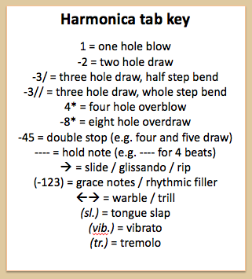
C harp:
3 5 -4 4 -4 5
You don't remember me
-3// -4 4 -3 -4 -2
But I remember you
3 5 -4 4 -4 5
‘Twas not so long ago
-3// -4 4 -3 -4 -2
You broke my heart in two
-2// -3// 4 -3 -2 -2// -3// 4 -3
Tears on my pillow, pain in my heart
-3 4 -4 5
Cau-sed by you

3 5 -4 4 -4 5
If we could start anew
-3// -4 4 -3 -4 -2
I wouldn't hesitate
3 5 -4 4 -4 5
I'd gladly take you back
-3// -4 4 -3 -4 -2
And tempt the hands of fate
-2// -3// 4 -3 -2 -2// -3// 4 -3
Tears on my pillow, pain in my heart
-3 4 -4 5
Cau-sed by you

-3// -3// -3 -4 4 4 -3// -3// -3 -4 4
Love is not a gadget, love is not a toy
-4/ -4/ -4/ -4/ -4 -4 -4 -4 -4/ -4/ -4/ -3 -4/ -4
When you find the one you love, she'll fill your he-art with joy

D harp:
3 5 -4 4 -4 5
If we could start anew
-3// -4 4 -3 -4 -2
I wouldn't hesitate
3 5 -4 4 -4 5
I'd gladly take you back
-3// -4 4 -3 -4 -2
And tempt the hands of fate
-2// -3// 4 -3 -2 -2// -3// 4 -3
Tears on my pillow, pain in my heart
-3 4 -4 5
Cau-sed by you

