Slow blues 1st position turnaround
Tabbed for diatonic harmonica by Liam Ward
Key: A (A harmonica in 1st position)

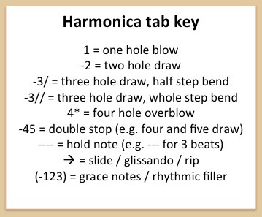
36 36 36 36 36 36
36 36 36 36 36 36 -25
4 -3/ -2 -2// 2 1
4 -3/ -2 -2// 2 1 1
-3/ -2

