Oh Danny Boy (Traditional)
Tabbed for diatonic harmonica by Liam Ward
Song key: C (C harp in 1st position)

-3 4 -4 5 -4 5 -6 6 5 -4 4 -3//
Oh, Danny boy, the pipes, the pipes are ca-all-ing
4 5 -5 6 -6 6 5 4 5 -4
From glen to glen, and down the mountain side
-3 4 -4 5 -4 5 -6 6 5 -4 4 -3//
The summer's gone, and all the roses fa-a-lling
4 4 -4 5 -5 5 -4 4 -3 4
It's you, it's you must go and I must bide

6 -6 -7 7 -7 -7 -6 6 -6 6 5 4
But come ye back when summer's in the me-ea-dow
6 -6 -7 7 -7 -7 -6 6 5 -4
Or when the valley's hushed and white with snow
6 6 6 8 -8 -8 7 -6 7 6 5 4
It's I'll be here in sunshine or in sha-a-dow
-3 4 -4 5 -6 6 5 -4 4 -3// -3 4
Oh, Danny boy, oh Danny boy, I love you so.

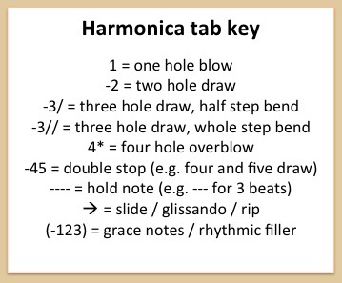
But when ye come, and all the flowers are dying
If I am dead, as dead I well may be
You'll come and find the place where I am lying
And kneel and say an Ave there for me
And I shall hear, though soft you tread above me
And all my grave will warmer, sweeter be
For you will bend and tell me that you love me
And I shall sleep in peace until you come to me.

