Merry Christmas Everyone (Shakin’ Stevens)
Tabbed for diatonic harmonica by Liam Ward
Song key: A (A harmonica is 1st position)

Verse:
5 5 -4 4 5 5 -4 4
Snow is falling, all around me
-6 -6 6 5 -5 6 5
Children playing, having fun
-4 -4 -4 4 5 6 6 5 -6 -4 4
It's the season, love and understandii-ing
-6 -6 6 5 -4 -3 4
Merry Christmas everyone

Verse 2:
Time for parties, and celebrations
People dancing, all night long
Time for presents, and exchanging kisses
Time for singing Christmas songs

Bridge:
5 5 5 -6 -6 6 6 6 5 -4
We're gonna have a party tonii-ight
5 5 5 -6 -6 -6
I'm gonna find that girl
5 6 6 6 6 6 6
Underneath the mistletoe
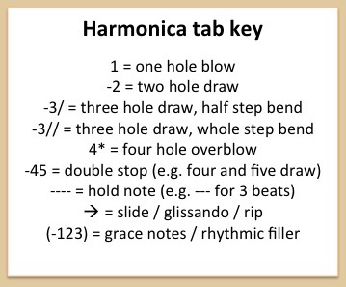
6 6 6 6 5 6
We'll kiss by candle light

