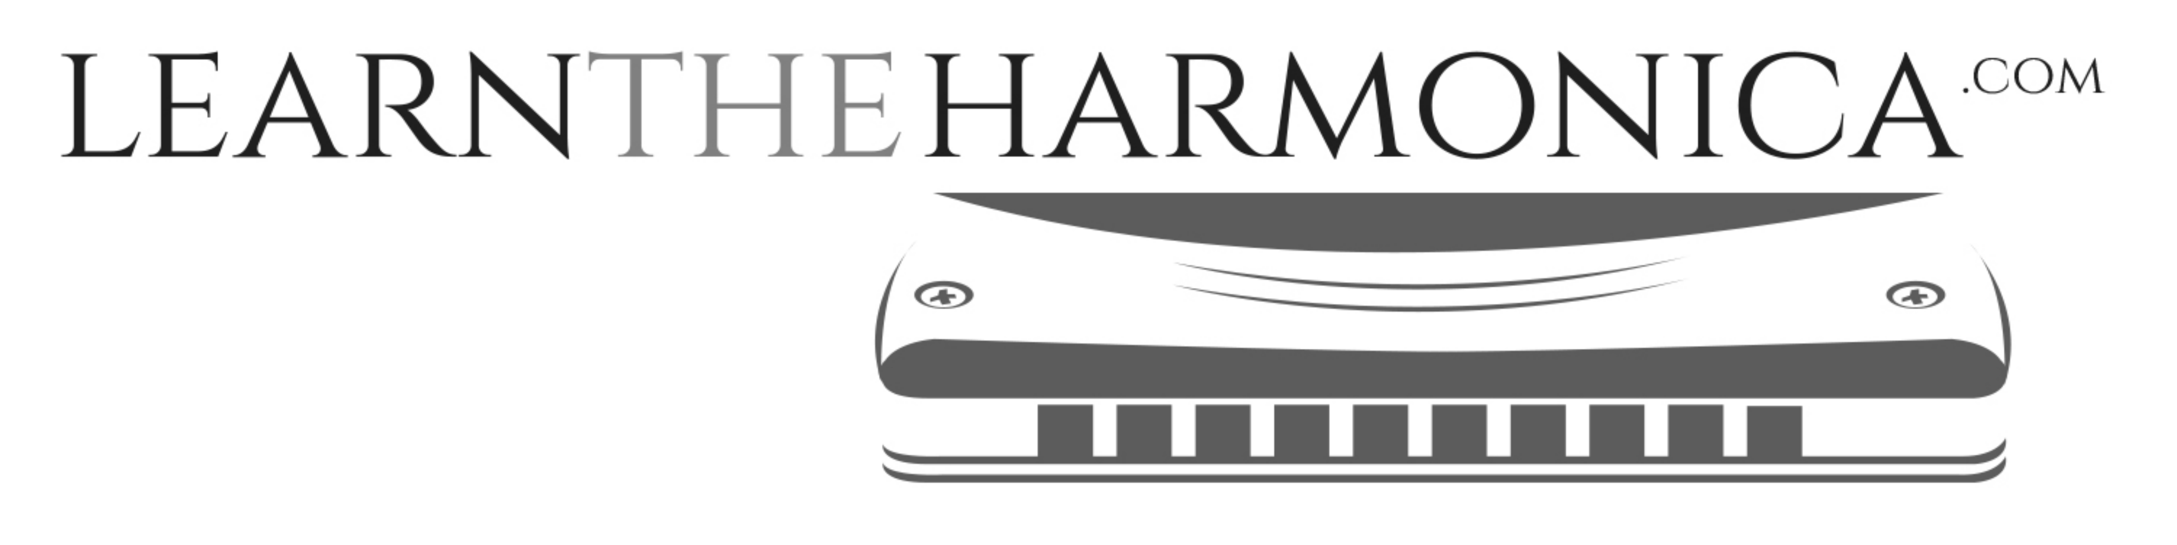

Hot Cross Buns (Traditional)
Tabbed for diatonic harmonica by Liam Ward
Song key: C (C harp in 1st position)

4 3 4 4 3 4
Hot cross buns! Hot cross buns!
6 -5 5 -4 4 -4 5 -5
One a penny, two a penny
6 3 4
Hot cross buns!

4 -4 5 -5 6 6
If you have no daughters
6 -5 5 -4 4
Give them to your sons
6 -5 5 -4 4 -4 5 -5
One a penny, two a penny
6 3 4
Hot cross buns!

