Jingle Bell Rock
Tabbed for diatonic harmonica by Liam Ward
Song key: C (C harp in 1st position)
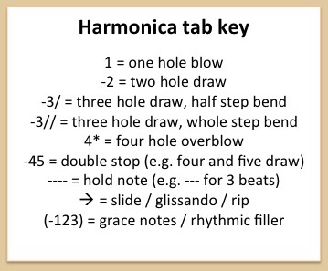
7 7 7 -7 -7 -7 -6 -7 -6 5
Jingle bell, jingle bell, jingle bell rock
-6 -7 -6 5 6 -6 -7 -6 -5
Jingle bells swing and jingle bells ring
-4 5 -5 6 -6 6 -4 5 -5 6
Snowing and blowing up bushels of fun
-6 -6/ -6 -6/ -6 -6 4* 4*
Now the jingle hop has begun
7 7 7 -7 -7 -7 -6 -7 -6 5
Jingle bell, jingle bell, jingle bell rock
-6 -7 -6 5 6 -6 -7 -6 -5
Jingle bells chime in jingle bell time
-4 5 -5 6 -6 6 -4 5 -5 6
Dancing and prancing in Jingle Bell Square
-6 -6 -7 6 7
In the frosty air
7 7 -8 7 -6 7 -8 7
What a bright time, it's the right time
-7 7 -7 -6 6 5
To rock the night away
7 7 -8 7 -6 7 -8 7
Jingle bell time is a swell time
6 6 -6 -6 -6 -6 -7 -6 6
To go gliding in a one-horse sleigh

7 7 7 -7 -7 -7 -6 -7 -6 5
Giddy-up jingle horse, pick up your feet
-6 -7 -6 5 6 -6
Jingle around the clock
-6 7 7 -8 -8 7 7 -6/ -6/ 7 -8
Mix and a-mingle in the jing-a-ling feet
7 -6 -7 7 -8 7
That's the jingle bell rock

