Rocker (Little Walter)
Tabbed for diatonic harmonica by Liam Ward
Key: E (A harmonica in 2nd position)

Learn the full song in my premium lesson!

Verse 1
A: -2// -2 -2 -2 -3/ -2 -2// -2 -2 -2 -2//
-2// -2 -2 -2 -2// -1-1/ (x3)

Verse 2
B: -2 -3-4 3 -3/ -2 2 -2 -1 3 -3-4 3 -3// -1 -2// -2
C: 3 -3/-4/ 3 -3/ -2 2 -1 3 -3/ -3/ -2 -1 -2// -2 -3/ -2 -2
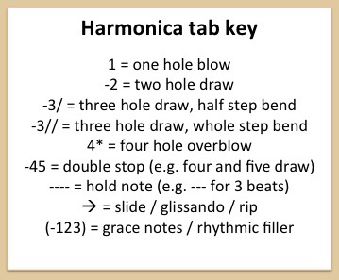
D: -3/ 4 -4 -3/ -2 -1 -3/ -2 -1 1 (-1 -2) -2 -3-4 -1 1 -1 -2 (2) -1 -1

