Yankee Doodle (Traditional)
Tabbed for diatonic harmonica by Liam Ward
Song key: C (C harp in 1st position)

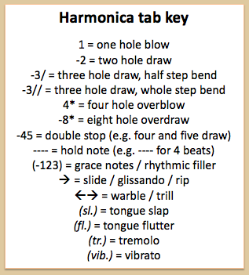
7 7 -8 8 7 8 -8
Yankee Doodle went to town
6 7 7 -8 8 7 -7
A-riding on a pony
7 7 -8 8 -9 8 -8
Stuck a feather in his cap
7 -7 6 -6 -7 7 7
And called it macaroni
-6 -7 -6 6 -6 -7 7
Yankee Doodle keep it up
6 -6 6 -5 5 6
Yankee Doodle Dandy
-6 -7 -6 6 -6 -7 7
Mind the music and the step
-6 6 7 -7 -8 7 7
And with the girls be handy

