And I Love Her (The Beatles)
Tabbed for diatonic harmonica by Liam Ward
Song key: Am (C harp in 4th position)
Intro (x3)
6 7 -7 -6

-4 5 -5 -7 -6 7
I give her all my love
-4 5 -5 -7 -6
That's all I do
-4 5 -5 -7 -6 7
And if you saw my love
7 -6 -5 5 -4
You'd love her, too
-6 6 -6 8
I-I love her

-4 5 -5 -7 -6 7
She gives my everything
-4 5 -5 -7 -6
And tenderly
-4 5 -5 -7 -6 7
The kiss my lover brings
7 -6 -5 5 -4
She brings to me
-6 6 -6 8
And I love her

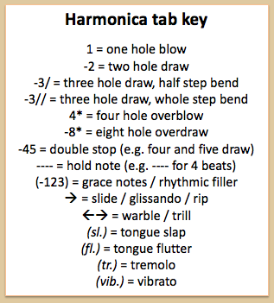

Verse 4
-4 5 -5 -7 -6 7
Bright are the stars that shine
-4 5 -5 -7 -6
Dark is the sky
-4 5 -5 -7 -6 7
I know this love of mine
7 -6 -5 5 -4
Will never die
-6 6 -6 8
And I love her
Middle eight
5 5 5 6
A love like ours
-7 6 5 6
Could never die
-7 6 5 6
As long as I
5 6 5 -4 -4
Have you near me

