Rudolph the Red-Nosed Reindeer
Tabbed for diatonic harmonica by Liam Ward
Song key: C (C harp in 1st position)

6 -6 6 5 7 -6 6
Rudolph the red-nosed reindeer
6 -6 6 -6 6 7 -7
had a very shiny nose
-5 6 -5 -4 -7 -6 6
and if you ever saw it
6 -6 6 -6 6 -6 5
you would even say it glows
6 -6 6 5 7 -6 6
All of the other reindeer
6 -6 6 -6 6 7 -7
used to laugh and call him names
-5 6 -5 -4 -7 -6 6
They never let poor Rudolph
6 -6 6 -6 6 -8 7
join in any reindeer games
-6 -6 7 -6 6 5 6
Then one foggy Christmas eve
-5 -6 6 -5 5
Santa came to say
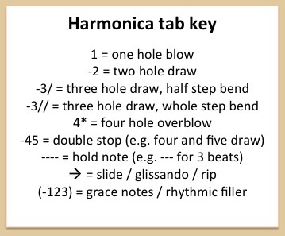
-4 5 6 -6 -7 -7 -7
Rudolph with your nose so bright
7 7 -7 -6 6 -5 -4
Won't you guide my sleigh tonight?
6 -6 6 5 7 -6 6
Then how the reindeer loved him
6 -6 6 -6 6 7 -7
as they shouted out with glee
-5 6 -5 -4 -7 -6 6
Rudolph the red-nosed reindeer
6 -6 6 -6 6 -8 7
you'll go down in history!

