Man With a Harmonica (Ennio Morricone)
Tabbed for diatonic harmonica by Liam Ward
Song key: Am

G harp:

-6 -6/ -6 -6/ -6

-6 -5 -6/ -6 -6/ -6

F harp:

-3 -3/ -3 -3/ -3

-3 -2 -3/ -3 -3/ -3

B harp:

-5 5 -5 5 -5

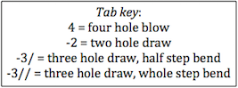
-5 -4/ 5 -5 5 -5

