Lonely This Christmas (Mud)
Tabbed for diatonic harmonica by Liam Ward
Song key: C (C harp in 1st position)

6 5 -4 5 4 4 -6 -6 -5 5 -4
Try to imagine a house that’s not a home
6 5 -4 5 4 4 -6 7 -6 7 -6 6
Try to imagine a Christmas all a-lo-one
7 -8 8 7 7 -8 8 7
That’s where I’ll be since you left me
7 7 7 8 7 -8
My tears could melt the snow
7 -8 8 7 -8 8 7
What can I do without you
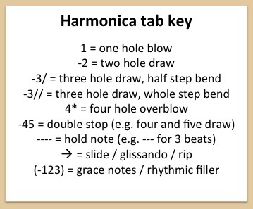
7 7 7 7 8 -8 7 -8
I’ve got no place, no place to go

7 -8 7 8 8 -8 -8 7
It’ll be lonely this Christmas
-6 -6 7 8 -8
Without you to hold
7 -8 7 8 8 -8 -8 7
It ll be lonely this Christmas
-6 7 8 -8
Lonely and cold
7 -8 7 9 8 -8 8 -8 7 -6 -6 7 8 -8
It’ll be cold, so-oo co-o-old, without you to hold
-9 8 -8 7
This Chri-i-stmas

